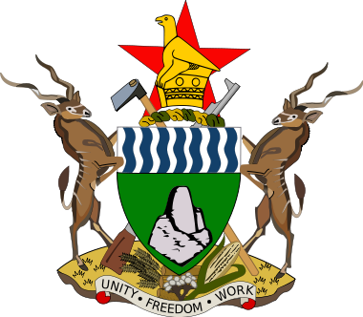
SMALL TOWNS WASH PROJECT BASELINE SURVEY SUPPORT

OBJECTIVES OF THE TOWN VISIT
- Supervise data collection by ZIMSTAT and the Qualitative Consultant
- Receive progress update regarding implementation of the programme
Day | Time | Activity
Thursday  19/02/2015 | 0800-0830 | Meeting with ZimSTAT-Progress Update (Quantitative Data Collection)
Thursday  19/02/2015 | 0830-0900 | Meeting with Town Secretary (Courtesy Call)
Thursday  19/02/2015 | 0900-1030 | Meeting with PSC (Progress Update, All Programme Components)
Thursday  19/02/2015 | 1030-1600 | Field Supervision- Baseline Survey – ZimSTAT
Friday  20/02/2015 | 0900-1030 | Exit meeting with PSC/ZimSTAT

